**THE PEARL EXAMINATIONS 2024**

**TERM II QUALITY ASSURANCE**

**TOP CLASS: (5 – 6 YEARS)**

**LEARNING AREA 5: LANGUAGAE DEVELOPMENT II**

**My name is: ………………………………..………………………….**

**My School is: ……………………………..……….…………………..**

**I am in: ………………………………..…………………………………………..**

1. **Read these sounds.**

s e n e t r z a p m f i n g o h

1. **Read and say the syllables.**

ma se po ha ve ta me de za ge no fa ye

1. **Read these words well.**

man get hat ten yam mat set rat red

1. **Read and draw**

a cat and a rat a man and a hat

a pen and a net a van and a fan

a boy and a girl a book and a pencil

1. 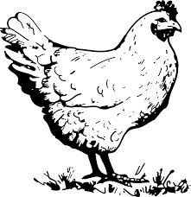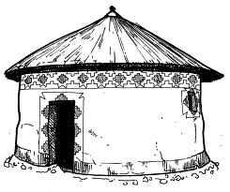**Write phrases for the pictures**

**_____________________**

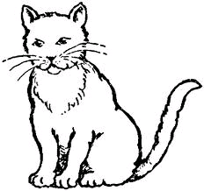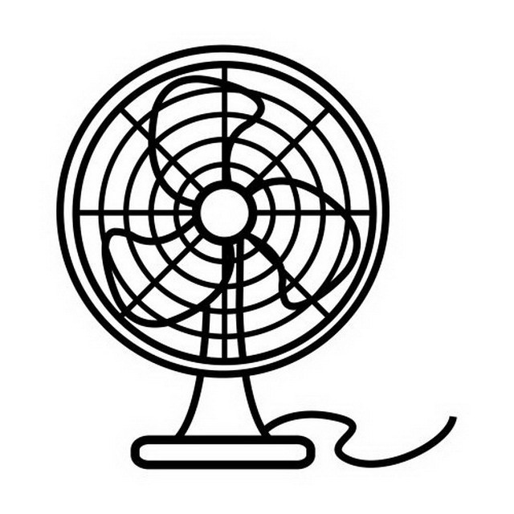

**______________________**

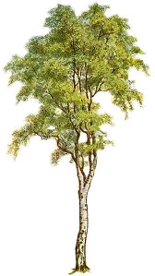

**__________________________________________________**

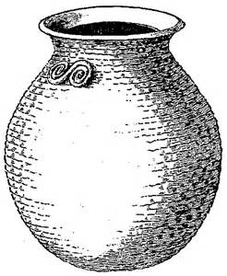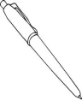

**_________________________**

1. **Fill in the missing letter**

t____p

y_____m

b____ll

1. **Colour the flower.**

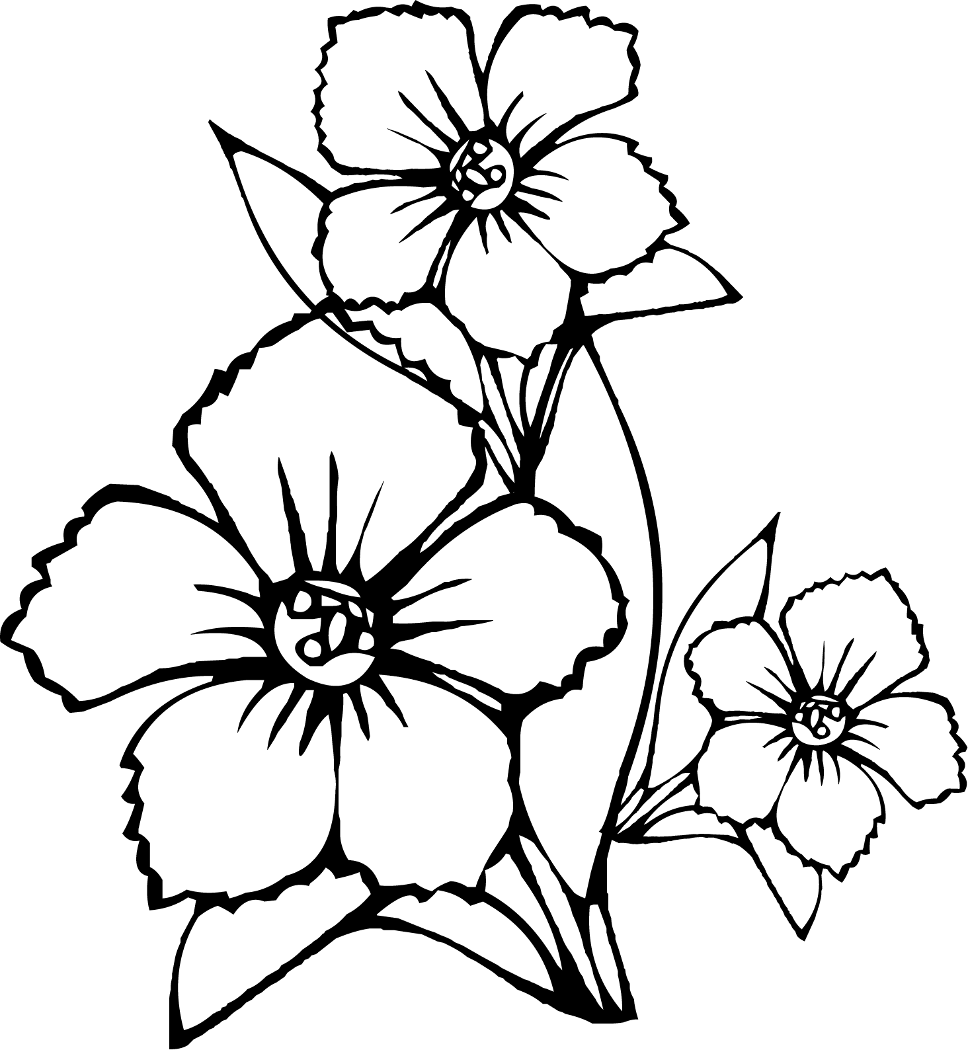

**END**